**MATHEMATICS SPECIALIST 3 & 4** Name_________________

**Test 1 2018 Weighting:4%**

**Section One: Calculator-free**

Reading Time: 2 minutes

Time Allowed: 19 minutes Total Marks: 19

Question 1 (7 marks)

The function $f$ is defined by $\left(x\right)=$ $\frac{1}{1-x}$.

(a) Evaluate $f(f\left(-1\right))$. (1 mark)

(b) Determine and simplify an expression for $f∘f\left(x\right)$. (2 marks)

(c) For $f∘f\left(x\right)$, state the

(i) domain. (2 marks)

(ii) range. (2 marks)

Question 2 (6 marks)

Let $f\left(x\right)=\sqrt{16+6x-x^{2}}, 0≤x≤8$. The graph of $y=f\left(x\right)$ is shown below.

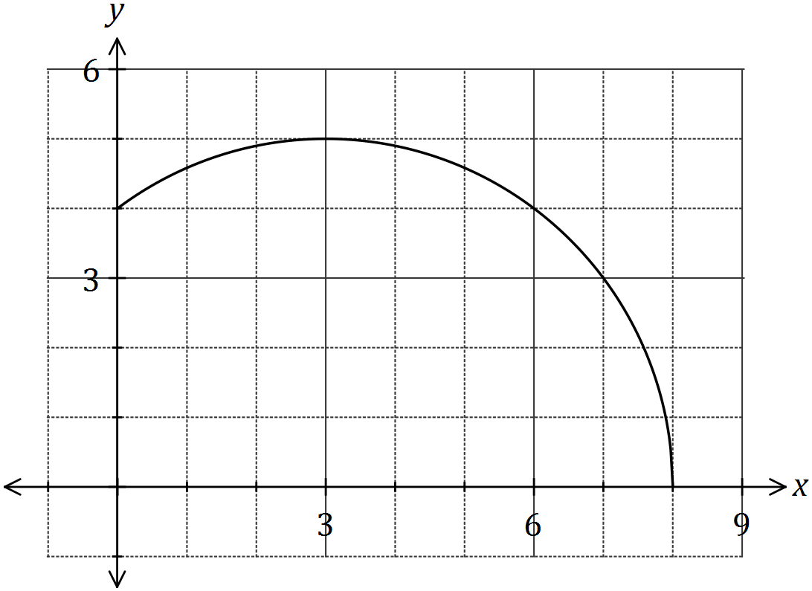

(a) In order that $y=f^{-1}(x)$ is a function, the domain of $f$ must be restricted to $k≤x≤8$. Explain why this restriction is necessary and state the minimum value of $k$. (2 marks)

(b) Using the restriction from (a), determine the inverse function of $f$ and its domain.

(4 marks)

Question 3 (6 marks)

On the axes below, draw the graph of $y=$ $\frac{x^{2}}{x^{2}-2x-3}$, clearly showing key features and the behaviour of the curve near the asymptotes.

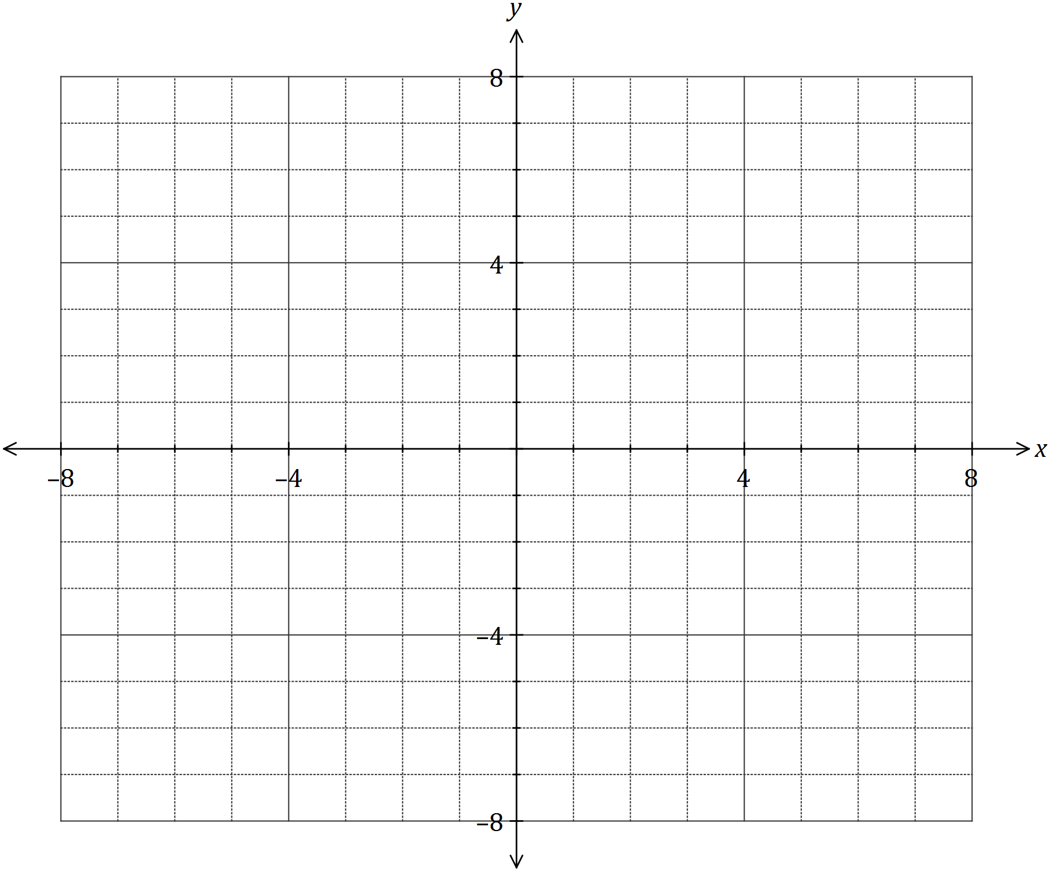

**MATHEMATICS SPECIALIST 3 & 4** Name_________________

**Test 1 2018**

**Section Two: Calculator-assumed**

Reading Time: 3 minutes

Time Allowed: 31 minutes Total Marks: 31

**Question 4 (5 marks)**

For each graph below that shows a function, on the same axes sketch the inverse function. For those that do not show a function, clearly indicate which graph(s) and briefly give your reasoning in the space below the graph.



Question 5 (8 marks)

The graph of $y=f(x)$ is drawn below.

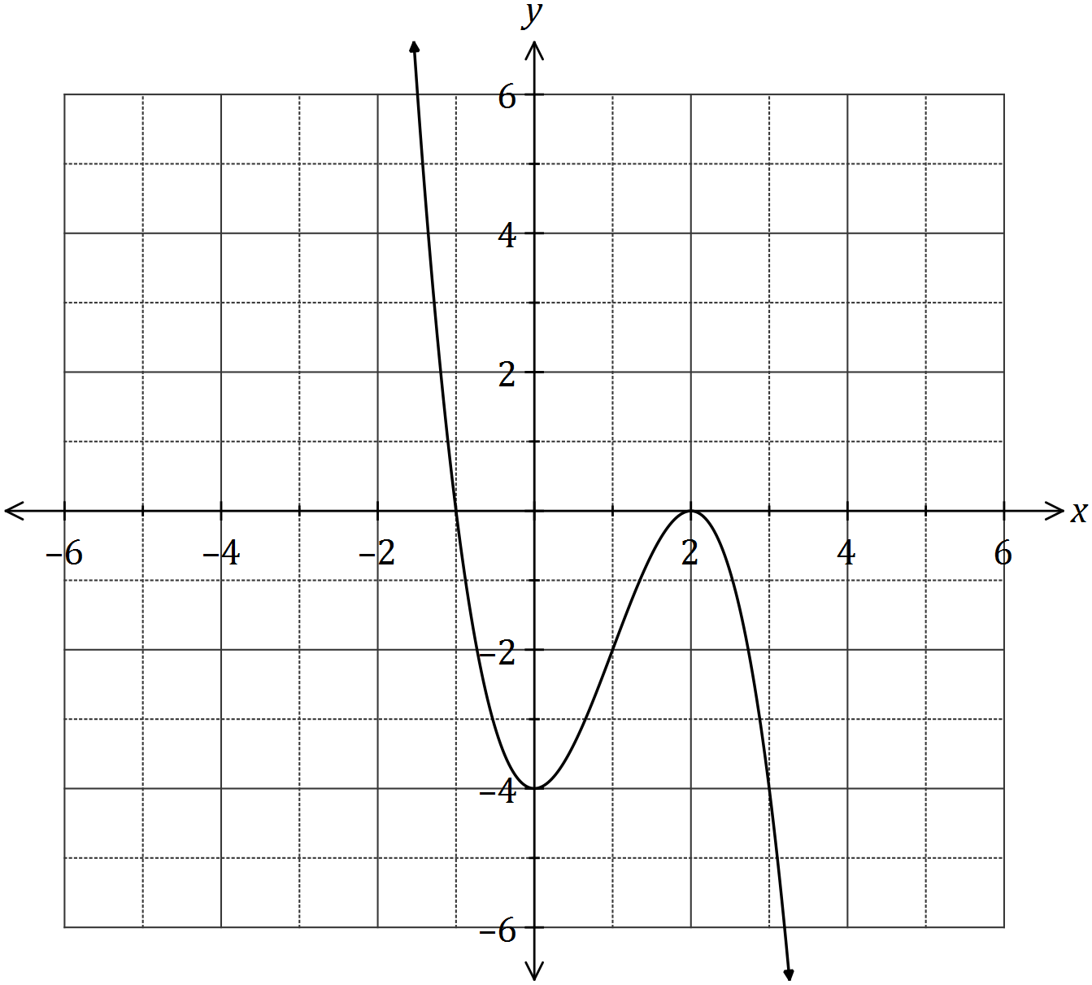

On the axes provided, sketch the graphs of

(a) $y=f(\left|x\right|)$. (2 marks)

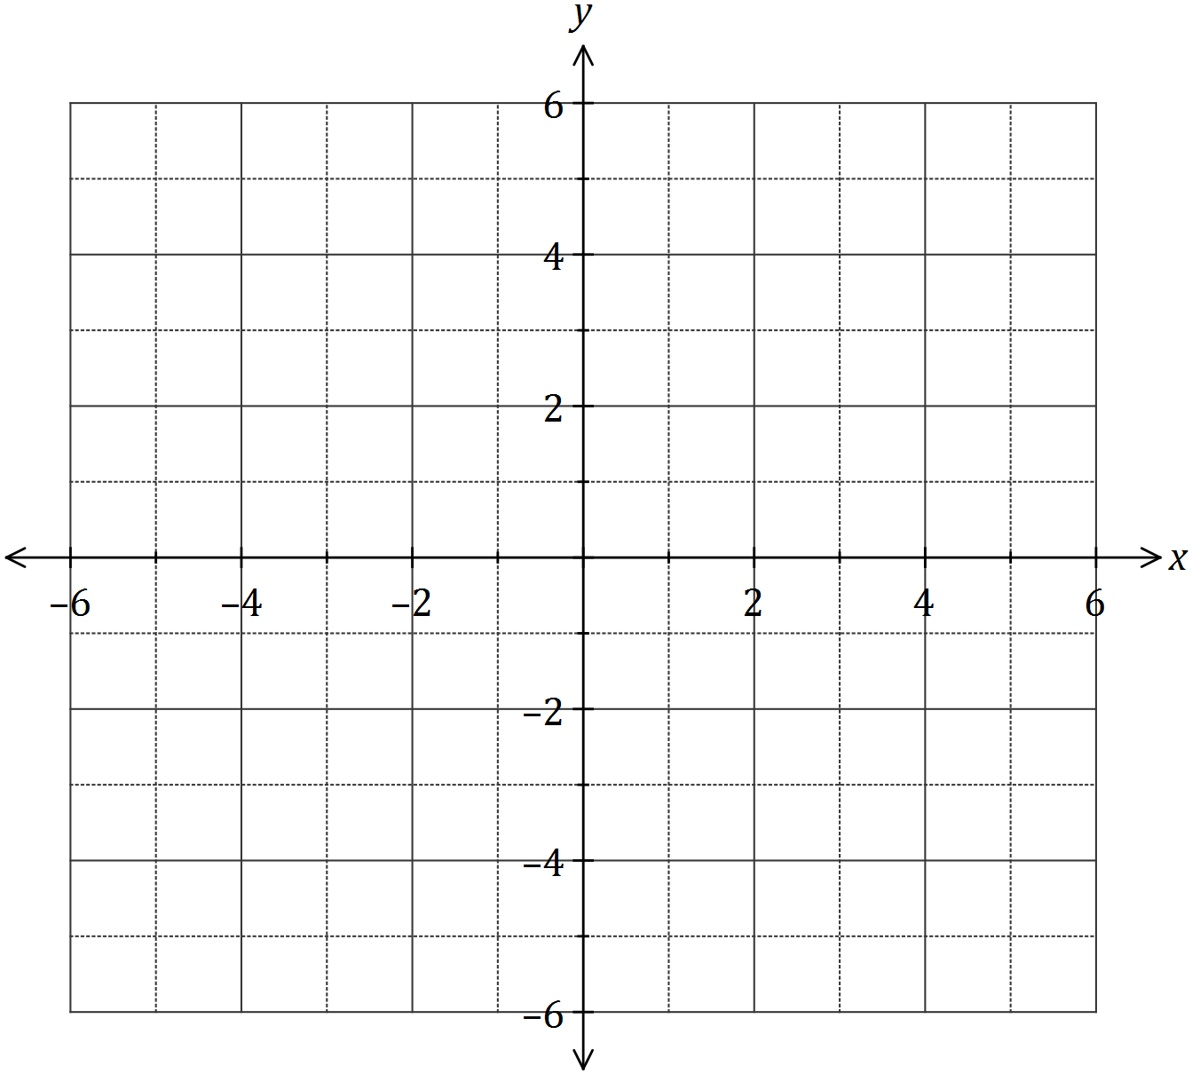

(b) $y=|f\left(x\right)|$. (2 marks)



(c) $y=$ $\frac{1}{f\left(x\right)}$. (4 marks)



Question 6 (9 marks)

(a) The graphs of the functions $g$ and $h$ are shown below.

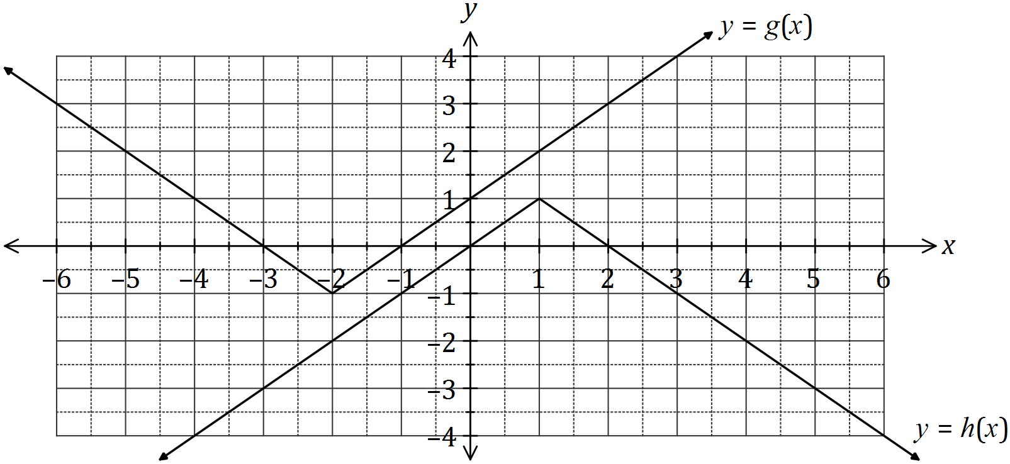

Determine the value(s) of $k$ if

(i) $k=h∘g(2)$. (1 mark)

(ii) $g\left(h\left(k\right)\right)=1$. (2 marks)

(b) The graph of $f\left(x\right)=a\left|x-p\right|+q$ is shown below.

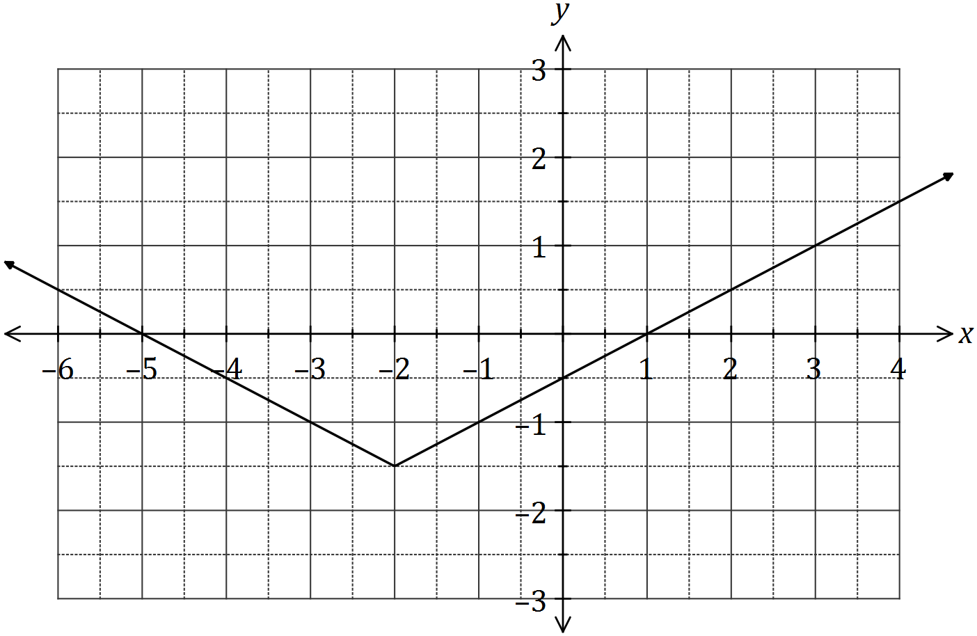

(i) Determine the value of the constants $a$, $p$ and $q$. (3 marks)

(ii) If the equation $\left|f\left(x\right)\right|=mx+c$ has an infinite number of solutions, determine the values of the positive constants $m$ and $c$. (3 marks)

Question 7 (9 marks)

A function is defined by $f\left(x\right)=$ $\frac{x^{2}+4x-12}{3x-7}$, $x≠0$.

(a) Determine the exact coordinates of all stationary points of the graph of $y=f(x)$.

(2 marks)

(b) Determine the equation(s) of the asymptote(s) of the graph $y=f(x)$. (3 marks)

(c) Sketch the graph $y=f(x)$ on the axes below. (4 marks)

